**TITLE: Shell Scripting Menu Driven Program**

**PROBLEM STATEMENT:**

Implement the following using shell scripting Menu driven program for

1. Find the factorial of a no.
2. Find greatest of three numbers
3. Find a prime no
4. Find whether a number is palindrome
5. Find whether a string is palindrome

**THEORY:**

* Shell Scripting: A shell script is a computer program designed to be run by the Unix/Linux shell which could be one of the following:The Bourne Shell,The C Shell,The Korn Shell,The GNU Bourne-Again Shell.A shell is a command-line interpreter and typical operations performed by shell scripts include file manipulation, program execution, and printing text.
* Factorial: the product of all positive integers less than or equal to a given positive integer and denoted by that integer and an exclamation point.
* Palindrome: A palindrome is a word, sentence, verse, or even number that reads the same backward or forward
* Prime Number: A prime number (or a prime) is a [natural number](https://en.wikipedia.org/wiki/Natural_number) greater than 1 that is not a [product](https://en.wikipedia.org/wiki/Product_(mathematics)) of two smaller natural numbers.

**PROGRAM:**

factorial(){ echo "Enter the number:" read num fact=1

for((i=1;i<=$num;i++))

{

fact=$((fact*i))

}

echo $fact is the factorial of $num

}

GreatestOfThree(){ echo "Enter Num1" read num1 echo "Enter Num2" read num2 echo "Enter Num3"

read num3

if [ $num1 -gt $num2 ] && [ $num1 -gt $num3 ] then

echo $num1 is the greatest elif [ $num2 -gt $num1 ] && [ $num2 -gt $num3 ] then

echo $num2 is the greatest else

echo $num3 is the greatest

fi

}

primeNumber(){ echo "Enter Number : " read n for((i=2; i<=$n/2; i++)) do ans=$(( n%i )) if [ $ans -eq 0 ] then

echo "$n is not a prime number." exit 0

fi

done

echo "$n is a prime number."

}

DigitPalindrome(){ echo "Enter a Number" read num

rev=""

temp=$num

while [ $num -gt 0 ]

do

s=$(( $num % 10 )) num=$(( $num / 10 )) rev=$( echo ${rev}${s} ) done

if [ $temp -eq $rev ]; then echo "$temp is palindrome" else echo "$temp is NOT palindrome"

fi

}

StringPalindrome(){ echo "Please Enter a String" read str echo " " length=${#str} i=$((length-1))

while [ $i -ge 0 ] do reverse=$reverse${str:$i:1} i=$((i-1))

done echo "Reverse of $str is $reverse" if [ "$str" == "$reverse" ] then echo "$str is palindrome" else echo "$str is not a palindrome"

fi }

Exit(){ exit 1; }

while : do echo "1.Factorial" echo "2.Greatest Of Three Numbers" echo "3.Prime Number" echo "4.Digit Palindrome" echo "5.String Palindrome" echo "6.Exit" echo "Enter your choice" read ch case $ch in

1. factorial;;
2. GreatestOfThree;;
3. primeNumber;;
4. DigitPalindrome;;
5. StringPalindrome;;
6. Exit;;

*)echo "Invalid choice";; esac

done

**OUTPUT:**

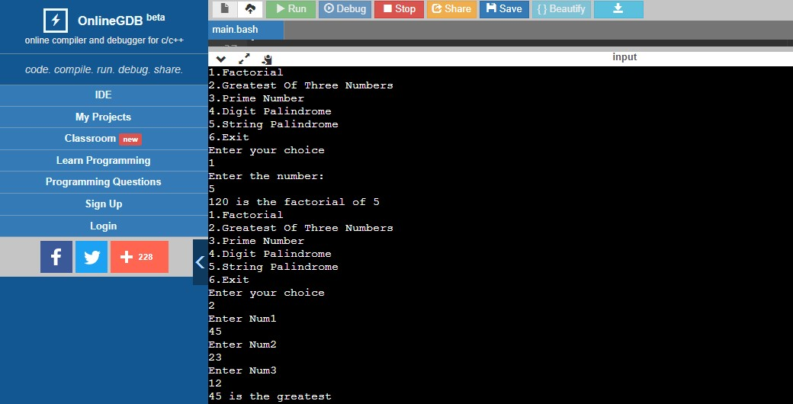

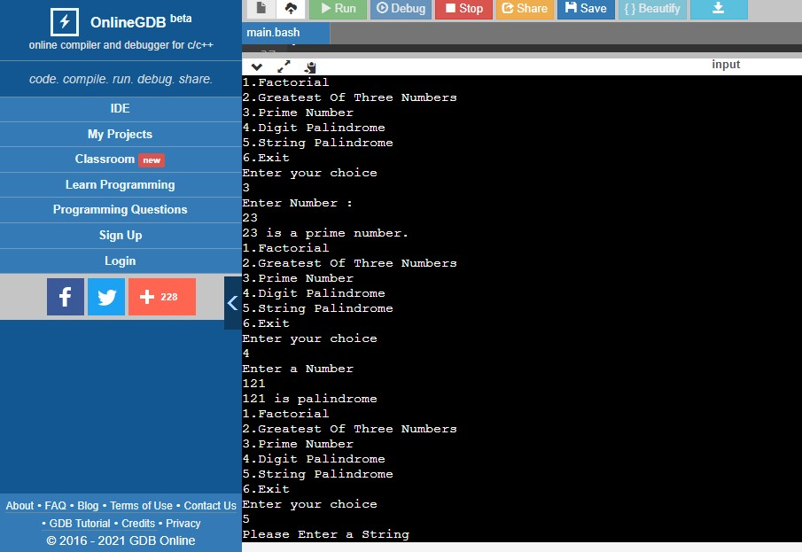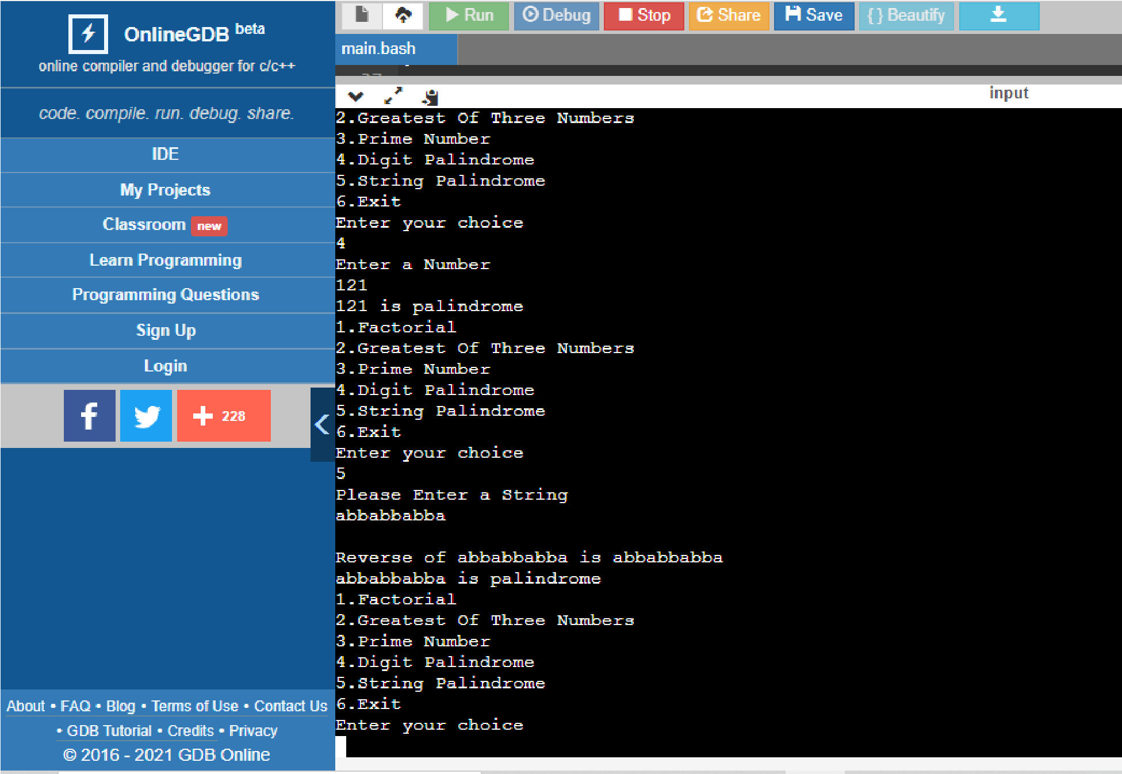

**CONCLUSION:**

Hence, we have successfully implemented the shell scripting menu driven code and understood its concepts theoretically.